CERTIFICATION

THIS IS TO CERTIFY that the following Agency Procurement through Notice to Proceed was posted in the Agency Media Website (www.rsu.edu.ph) on the 25th day of May 2023.
- Posted the files, as follows:

Notice to Proceed for the Procurement of Office, ICT, and Janitorial Supplies for Romblon State University (ABC PhP3,086,948.00, QTY 24,534), Solicitation No. RSU-23-01-002

Issued this 25th day of May 2023 at RSU-Office of Media and Public Affairs, Odiongan, Romblon.
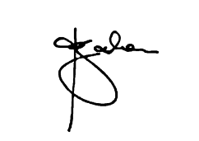
Published By:
ANA D. GADON
_____________________________________
Signature over Printed Name of Media Administrator

Acknowledged By:
_____________________________________
Signature over Printed Name of Requestor

