- ROMBLON STATE UNIVERSITY VISION AND MISSION

VISION
A research-based academic institution committed to excellence and service in nurturing globally competitive workforce towards sustainable development.

MISSION
The Romblon State University shall nurture an academic environment that:
- provides advanced education, higher technological and professional instruction;
- provides technical expertise in agriculture and fisheries, forestry, engineering and technology, education, humanities, sciences and other relevant fields of study and
- collaborates with other institutions and communities through responsive, relevant and research-based extension services.

THE RSU COLLEGE OF ENGINEERING AND TECHNOLOGY OUTCOMES-BASED EDUCATION FRAMEWORK

RSU VISION AND MISSION

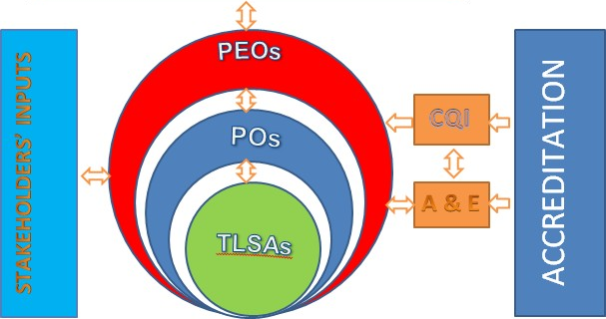

Figure 1. The RSU CET Framework.

The RSU CET programs adapt the Outcomes-Based Education (OBE) framework as shown (Fig. 1). At a glance, it is a 10 = 1 with an overhead dash. The number 10 usually depicts completeness and totality; equal sign depicts result; the number 1 depicts unity or common vision, and the overhead dash depicts sustainability. Thus, the unified, meaningful, and synergistic interaction among all internal and external stakeholders will surely result in the attainment of a common vision and mission in a sustainable manner.
To attain this, the core Teaching and Learning Strategies and Activities (TLSAs) must be properly aligned with the Program Outcomes (POs), Program Educational Objectives (PEOs), and the university’s vision and mission. It must continuously undergo Assessment and Evaluation (A & E) internally so that the necessary improvements will be determined and immediately implemented. The internal and external stakeholders which form the Program Advisory Council (PAC) will be periodically consulted to obtain feedback and inputs for the improvement of the program. This will ensure Continuous Quality Improvement (CQI). Furthermore, the program must be subjected to local, national, and international accreditation to ensure quality and global competitiveness.

The formulation of CET OBE Framework is anchored on CHED handbook on Typology, Outcomes-Based Education (OBE), and Institutional Sustainability Assessment (ISA) 2014. It is supported by CMO No. 37 series of 2012, known as the Policies, Standards, and Guidelines on the Establishment of an Outcome-Based Education System in HEIs offering Engineering Programs.

- PROGRAM EDUCATIONAL OBJECTIVES (PEO)
The Program educational objectives (PEOs) are broad statements that describe what graduates are expected to achieve in their professional and career practice three to five years after graduation. These are based on the needs of the program’s constituents.
The Mechanical Engineering Program Educational Objectives and Relationship to RSU Mission:
Graduates from the Mechanical Engineering program are expected to attain or achieve the following Program Educational Objectives 3 - 5 years of graduation: | MISSION
 | 1 | 2 | 3
- Establish technical expertise in the field of mechanical engineering and gain recognition for the work in their respective fields. | √ | √ | √
- Design and develop relevant technology using skills and resourcefulness; develop creative and innovative solutions to engineering problems; and identify, search and solve new technical challenges. | √ | √ | √
- Keep abreast of emerging technologies, continually learn new knowledge and actively participate in professional communities to nourish ever-developing careers. | √ | √ | √
- Demonstrate leadership and initiative to ethically advance professional and organizational goals, and show commitment to teamwork while working with others of diverse cultural and interdisciplinary backgrounds. | √ | √ | √

- PROGRAM OUTCOMES:
Program Outcomes (Pos) specify the what students are expected to know and be able to do by the time of graduation. These relate to skills, knowledge, and behaviors that students acquire as they progress through the program.

The POs of the ME program are based on the CMO. 97, series of 2017. The total POs of the CMO is twelve (12) and was adopted by the program.
By the time of graduation, the ME students shall have the ability to:

- apply knowledge of mathematics and science to solve complex mechanical engineering problems;
- design and conduct experiments as well as to analyze and interpret data;
- design a system, component or process to meet desired needs within realistic constraints, in accordance with standards;
- function on multi-disciplinary and multi-cultural teams;
- identify, formulate and solve complex mechanical engineering problems;
- understand professional, social and ethical responsibility;
- communicate effectively both in Filipino and English languages through writing, listening, presenting, observing, questioning, focusing, and connecting complex engineering activities with various communities including engineering experts and society at large;
- understand the impact of mechanical engineering solutions in a global, economic, environmental and societal context;
- recognize the need for, and life-long learning;
- know contemporary issues;
- use techniques, skills and modern engineering tools necessary for mechanical engineering practice; and
- know and understand engineering and management principles as a member and leader of a team, and to manage projects in a multidisciplinary environment.

